About Supermarket Billing System in C++:

Supermarket billing system is a very simple mini project in C++, built as a console application without using graphics features. It’s just a demonstration of the use of file handling and stream class in C++ language.

The project is relatively simple to understand as there are just a few features. Understanding the source code will give you the idea regarding file handling: how to add, remove, edit, and search data or info to/from file.

Listed below are the key features of this project:

* **Bill Report**: It shows the bill report of all the items added in supermarket billing system.
* **Add, Remove or Edit items**: With this feature you can add, remove and modify item details. In add items, you can add information or details such as item no., item name, manufacturing date, price, quantity, tax percent, and many more.
* **Show item details**: This feature allows users to see the items and the corresponding details given for the item while adding the item.

Output Screens:

[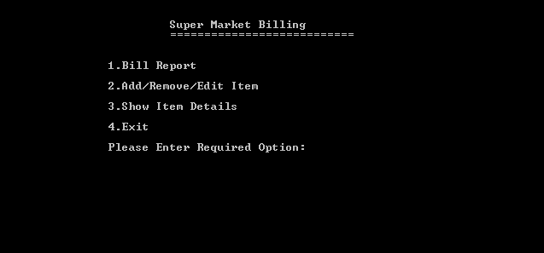](https://www.codewithc.com/wp-content/uploads/2014/05/supermarket-billing-menu.png)Main Menu[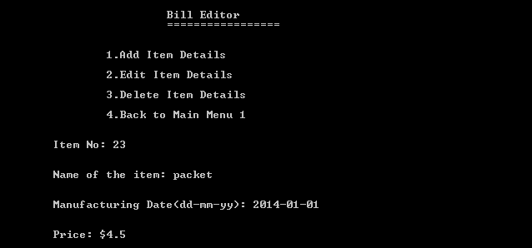](https://www.codewithc.com/wp-content/uploads/2014/05/supermarket-add-items-details.png)Add Items

Some rooms for improvements in this supermarket billing system project include the use of ‘while’ loop instead of the ‘goto’ label. Many programmers consider the use of ‘goto’ label to be not good or less efficient.

You can take the use of ‘goto’ label as the prime defect of this project. It has been used to jump from one menu to another within the program. Also, for editing and deleting the recorded items, separate functions have not been used.